Complaints Page

The concept of this project was to use react-redux to create a simple page that allows users to submit a complaint to the support team, building it was split into 2 parts

1. Complaint info

In this part I designed the left part of the page that allows the user to select the type of the complaint and input the name

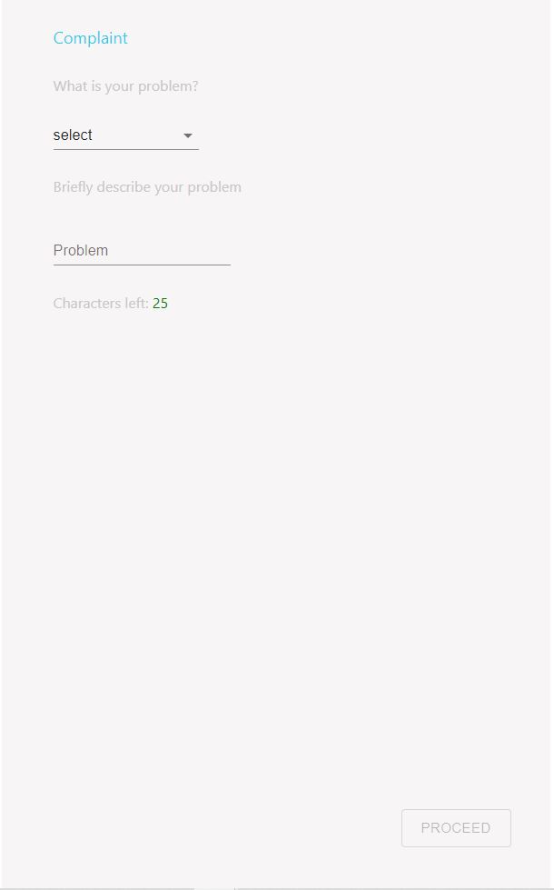

The proceed button stays disabled until the user inputs a valid name for the complaint that is under 25 letters if the user goes over the limit the button will be disabled again, and once the user clicks the proceed button the top of the messaging section will be enabled and the user will be allowed to send a message to support explaining their problem.

